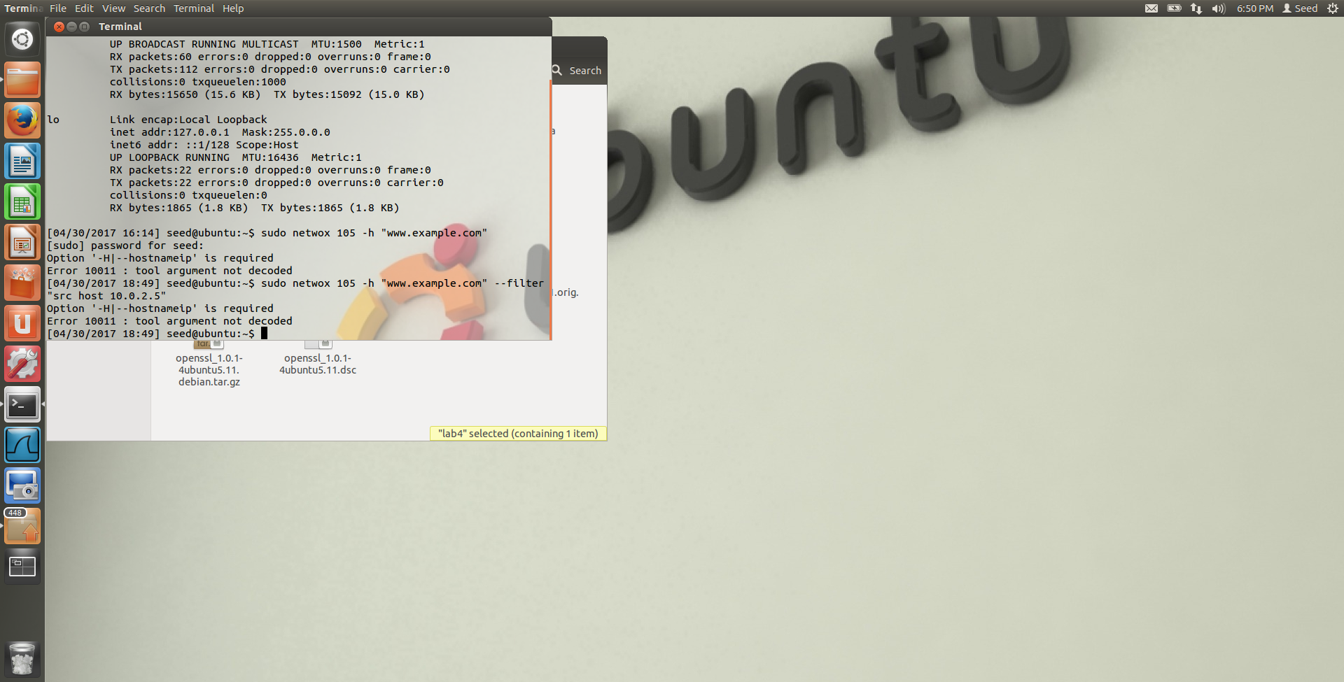

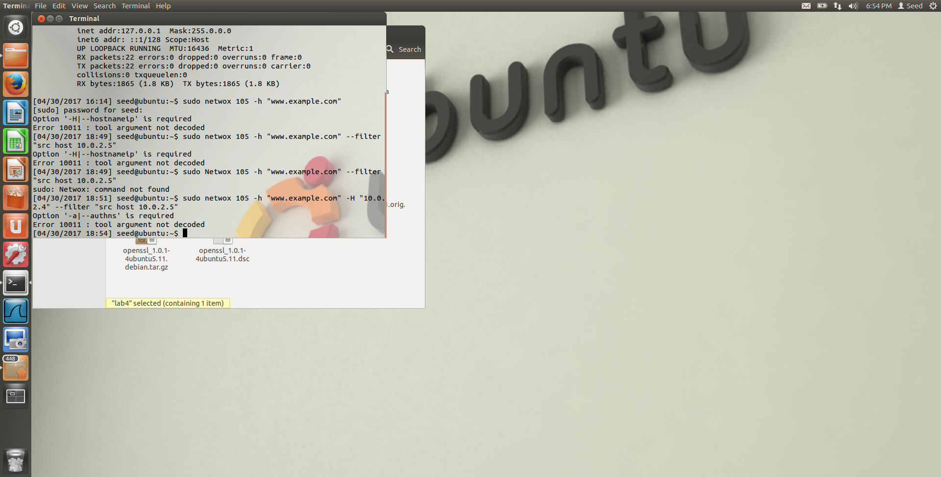

This is from attempting task 2 of the lab. I was not sure what this error was that I kept getting, but was not sure what needed to change. I think it could be because the source IP was incorrect or something.

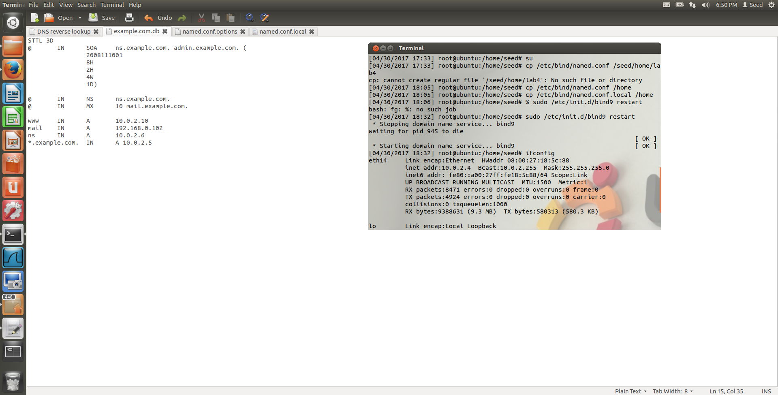

This was just to show that I was able to get the DNS server to start up.

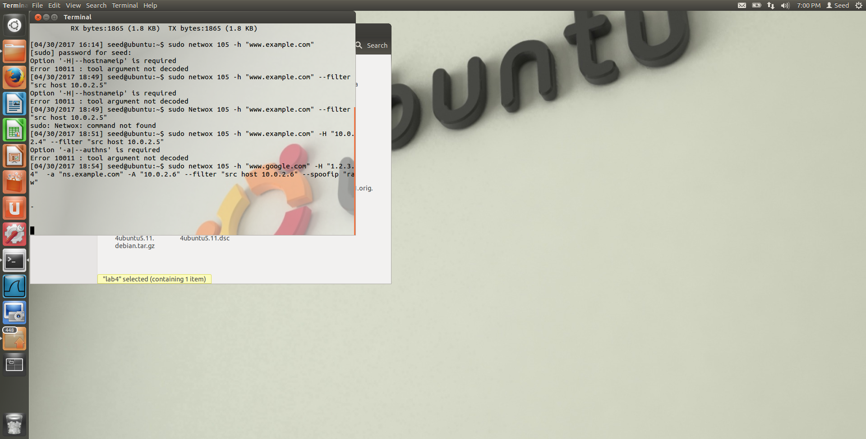

This is after attempting task 3. I am not sure what exactly the problem was, but it seemed to be waiting for another command. I could keep hitting enter and it would insert blank lines.

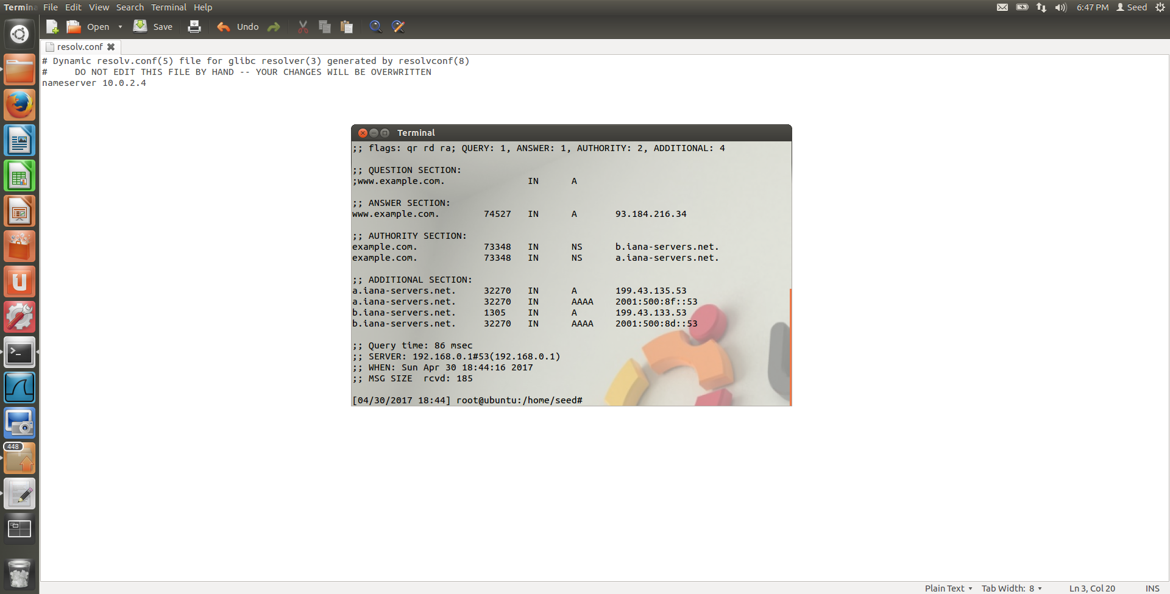

This was the output in 2.4 of the lab